
thesis results
Comparative study of ML , Deep learning and GenAI on Anomaly detection

May 18, 2026
ASAD MSAI 4 243260
FALL 2024

ML Training results
In this study, XGBoost and Support Vector Machine (SVM) were applied to detect anomalies in HDFS log data using event count features from a highly imbalanced dataset (558,223 normal vs 16,838 anomalies). XGBoost achieved near-perfect performance, with an anomaly precision of 0.9985, recall of 0.9997, and F1-score of 0.9991, making only 5 false positive errors and missing just 1 anomaly out of 3,368 in the test set. In comparison, SVM also performed strongly, achieving an anomaly precision of 0.9634, recall of 0.9994, and F1-score of 0.9811, but produced 128 false positives and missed 2 anomalies. While both models demonstrated excellent recall, indicating strong anomaly detection capability, XGBoost clearly outperformed SVM in precision and overall F1-score, meaning it generated far fewer false alarms while maintaining almost perfect detection. This difference is mainly due to XGBoost’s ability to capture complex, non-linear relationships in the data, whereas SVM (in its linear form) is more limited. Overall, these results show that XGBoost provides a more accurate and reliable solution for anomaly detection in structured log data.
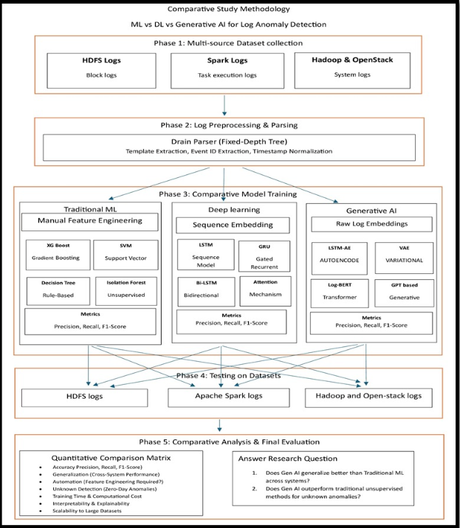
Data training Code on
SVM code
SVM Results
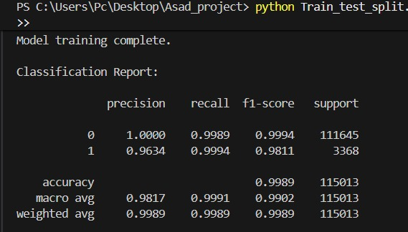
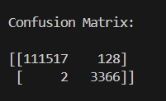
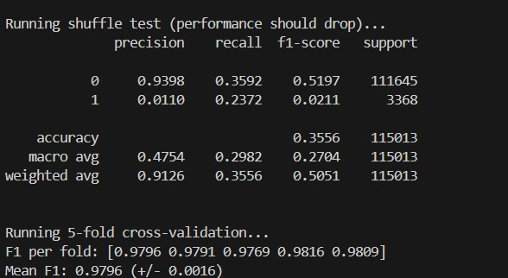
XGboost code
from xgboost import XGBClassifier
scale_pos_weight = (y_train == 0).sum() / (y_train == 1).sum()
model = XGBClassifier(
n_estimators=200,
max_depth=6,
learning_rate=0.1,
subsample=0.8,
colsample_bytree=0.8,
scale_pos_weight=scale_pos_weight,
random_state=42,
n_jobs=-1
)
model.fit(X_train, y_train)
Results
